CARING FOR

YOUR BRACE & TEETH

Q How long will I have to wear the brace?

A It really depends on how much work there is to do and how far your teeth need to be moved.

Your dentist or orthodontist will be able to give you advice about your brace and teeth. If you don't do what they say, the brace can take longer to work and the treatment may be unsuccessful. If your brace is damaged or broken this can also delay the treatment.

Q How often should I see the orthodontist or dentist while I am wearing my brace?

A You will need to have your brace adjusted regularly to make sure it is working properly. Usually you will have an appointment roughly every six to eight weeks. It is extremely important that you go to these appointments otherwise the brace will take a lot longer to work.

Q Will my mouth be sore in between visits?

A Your mouth is very sensitive to change and it will take you a few days to get used to wearing your brace. At first, your teeth may feel uncomfortable because of the pressure put onto them by the brace. It may also feel uncomfortable and tight against your teeth after it has been adjusted. Painkillers like ibuprofen can help.

Some parts of the brace may also cause discomfort to your gums and lips, causing sore spots. Your dentist or orthodontist can give you clear wax to place over the part of the brace that is causing discomfort. However, if after a few days any part of your brace is causing continual soreness, you should go back to your dentist or orthodontist.

Q Will I be able to speak normally?

A Sometimes when a brace is fitted, it may affect your speech and cause problems in pronouncing certain words. Lisping may also be a problem at first, but most people soon adapt and quickly begin to speak clearly within a few days.

Q Is there anything I should avoid?

A Nail biting and chewing your pen or pencil can damage or break your brace.

Q Can I do sports while wearing my brace?

A If you have a removable brace then it is best to take it out and put it in a brace case. You can buy these from your dentist, or from most large chemists. If you do remove your brace, it is important to use a mouthguard and then put your brace back in as soon as possible. It is also best to take your brace out if you are swimming. If you have a fixed brace you should wear a special mouthguard for use during contact sports over the brace. Your dentist will be able to make you one.

Q Can I still play musical instruments?

A Braces may affect playing wind instruments, although with practice you should get used to it. If your brace is removable then it is best to remove it and store it safely in a brace case. Put it back in straight after you have finished playing.

Q Can I eat normally?

A Eating the wrong foods can damage or even break your brace. For the first few days, it may be better to keep to soft foods.

Whether you have a removable or a fixed brace you should avoid sticky, chewy and sugary foods. Chewing-gum is not recommended as it can stick to your brace. Avoid hard foods such as whole apples, carrots, French bread and crusty rolls. These foods could break the orthodontic wires and brackets.

At first it is best to cut your food into small pieces and keep to a soft diet. Food may build up in the brackets and in between your teeth and will need careful cleaning to remove it.

Avoid fizzy drinks and natural fruit juices as these are often high in sugar and can be acidic. This can lead to tooth decay and erosion. Fizzy drinks can also stain the orthodontic brackets. If you do drink fizzy drinks, avoid constant sipping of the drink and use a straw. Water and plain milk are the safest drinks.

Q Why should I look after my mouth when I have a brace?

A It is extremely important that you take the time and effort needed to keep your teeth and braces clean. This will help you avoid problems such as dental decay, inflamed gums, and 'tooth decalcification'. Decalcification is when you lose the mineral calcium from the surface of your teeth, and this may leave white spots on your teeth after the brace is removed.

It is also important to keep having routine dental examinations with your regular dentist while you are having orthodontic treatment. This is to make sure that your teeth and mouth stay healthy.

Q What if I lose or damage my brace?

A If you lose or damage your brace tell your dentist or orthodontist as soon as possible. Do not wait until your next routine appointment because any time you are not wearing your brace, or it is not in the correct position, affects your treatment and makes it more likely that your teeth will go back to their old position. Dentists will charge for lost or broken braces.

Q How should I clean my mouth and brace?
A Clean your teeth and the brace thoroughly after each meal. Pay special attention to each individual tooth and the gum line around it.

Q What products can help me to look after my mouth and brace?

A The following products will help:

- Total care toothpastes. - These contain a number of active ingredients such as fluoride or tartar control to make them an effective multi-action toothpaste. They help control plaque, dental decay and gum disease while also freshening your breath.

- Electric or battery-operated toothbrushes. - These can be used, although with care, as long as you can get to all your teeth. Ask your dentist or orthodontist about special small brushes which are suitable for cleaning your teeth when wearing a brace.

- Interdental brushes. - These can help you clean a fixed brace. They can get in between your teeth and are ideal for cleaning around the brackets of a fixed brace. Your dentist or chemist should stock these.

- Floss threaders. - You can use these to help you get dental floss under the orthodontic wires to remove trapped food particles.

- Disclosing tablets. - These contain a harmless dye which stains the dental plaque. This makes it easier to see where the plaque is when you are brushing. This helps you to make sure that you are brushing your teeth properly. Your dentist, chemist or supermarket will stock these.

- Fluoride mouthrinses. - Using fluoride mouthrinses regularly can help to prevent dental decay and tooth decalcification. You should only use them under the guidance and instruction of your dentist or orthodontist.

Q How do I clean my removable brace?

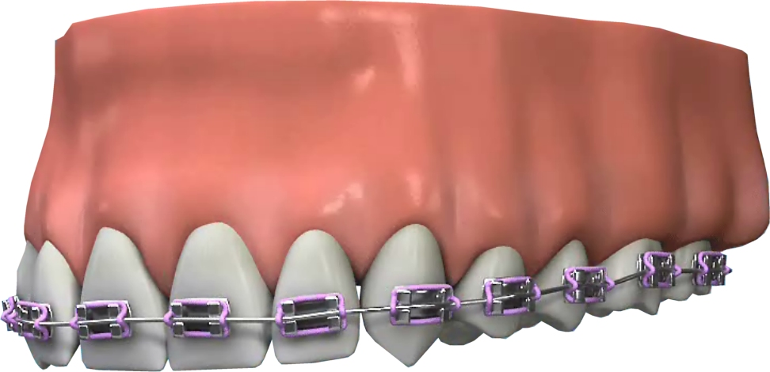
A Your dentist or orthodontist will be able to show you special techniques for cleaning your brace. It is best to clean your brace over a sink full of water so that it isn't damaged if you drop it. Keep a separate toothbrush just for cleaning your brace. Use toothpaste to clean it. Gently brush the brace and rinse it thoroughly with fresh water afterwards.

